# NOAH Tool

## General comments:

Only one of the window tabs is required in order to use the NOAH Tool. This depends on whether it is Calibration or RTC that is desired.

It is required to check the *Overwrite existing config file* in order to use the input data from the interface. If this is not checked the input from the existing configuration file with the model name is used.



A folder with the timestamp of the beginning of the computation is created in *NOAH_RTC_Tool\output*. (e.g. NOAH_RTC_Tool\output\2020-06-11_10-19-18). This folder contains the results and plots from the computation.

## Real Time Control

The real time control is computed as simple rule-based control. If the water level in a node exceeds a certain level an actuator is activated.

The required actuators are expected to be implemented in the model before the RTC tool is used.   
The following is an explanation on how different actuators are applied.

All nodes can be used as sensors since this only require the depth in the node.

### Orifice

An orifice is a structure that can be either open or closed and thus allowing water to pass towards the downstream part of the system.

The setting that is defined in the interface is the fraction open (i.e. 0 means closed and 1 means open) and should be in the range between 0 and 1.

Example:

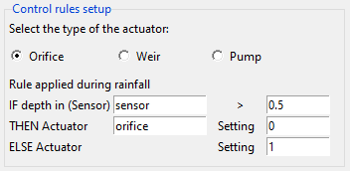

If the depth in the sensor exceeds 0.5 meters the orifice will close. If the depth is below 0.5 the orifice will be open.

Other settings between 0 and 1 can be applied in order to let smaller amounts of water through the weir.

Note that the time that it takes for the orifice to change position should be defined beforehand in the SWMM model.

### Weir

The *setting* that is defined corresponds to the fraction that is open.

The height of the weir is then:

$$weir height= Inlet offset+\left(1-X\right)*height$$

where X is the setting that is inputted in the GUI.

Thus, a setting of 1 means that the weir is fully open (the lowest point) while a setting of 0 means that the weir is closed (lifted to its maximum height).

Example:

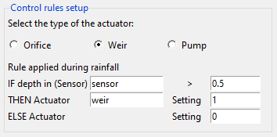

If the depth in the node that is named sensor exceeds 0.5 meters, the weir will be fully open and else it will be fully closed.

In the example the sensor is located upstream of the weir. This means that a high water level will open the weir and let water flow further down in the system.

If the sensor is located downstream of the weir the setting should typically be swapped, such that a high water level causes the weir to close and prevent water from flowing down in the system.

Other settings between 0 and 1 can be applied. This could be to lift the weir in case of rising water level but still allow water to flow over the weir when the water level reaches a certain height.

## Optimization of Real Time Control

The optimization of the real time control is defined in the window with optimization parameters.

The variable that is optimized is always the “activation depth”. This is the depth that should be measured in the sensor node before the actuator (orifice, weir or pump) reacts and changes its position.

Optimization is only applied if the “Use Optimization” field is checked. If this is not the case the simulation will just run with the setup that is defined in the Control rule setup.

The optimization is done by a “two-step-optimization” which first makes a certain number of simulations within the entire parameter space and afterwards runs a simplex algorithm with starting point as the minimum value from the initial step.

Example:

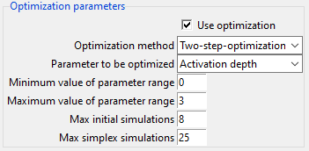

The parameter range is defined to be between 0 and 3 meters. No setting outside this range can be found. This should typically be the lowest and highest depth of the sensor node.   
8 Simulations are run within this range and afterwards a simplex algorithm is initialized from the lowest point and runs either 25 iterations or until the algorithm has converged and reached the minimum value.

The scope of the optimization is to minimize either the total volume or the frequency (number of events) where flooding or CSO occur. This is computed from a selected number of nodes defined by their node ID.   
The node ID’s can be defined in three field or provided as a list of nodes separated by “,” if more than three nodes are to be computed. If nodes are typed in tin the list the the upper three fields will be ignored.

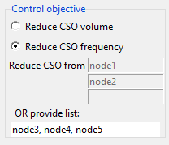

In this case the number of CSO events are to be reduced from node3, node 4 and node5. Node1 and node2 are not included in the computation.

The CSO settings frame are used to define how a CSO event is computed. These are predefined but can be adjusted if desired.

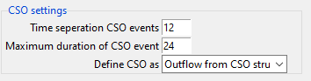

If CSO’s occur within the “separation time” they are counted as one event.   
If one event lasts longer than “maximum duration” they are counted as several events.   
The CSO definition depends on the model. If the CSO’s are computed as outflow from an outlet, the “Outflow from CSO structure” should be selected whereas “Flooding above ground” should be selected if the flooding is computed as flooding from nodes.

